Lawrenceburg Public Library District

**Welcome to LPLD’s Minecraft and Munchies**

As we learn how to read a recipe in order to make our munchies, we will learn to use a variety of kitchen tools/skills. Many of these skills (cutting, peeling, grating, chopping, etc.) offer elements that, if done incorrectly, may be potentially dangerous. Participants will be closely supervised by LPLD programming staff and/or volunteers who are well trained in using kitchen tools in a safe and respectful way.

Kitchen knives can be potentially dangerous. As is often the case, prevention is the best medicine. We will go over knife safety before any knives are used by the participants. With proper care and attentiveness, knives are safe and an incredibly useful and rewarding kitchen tool.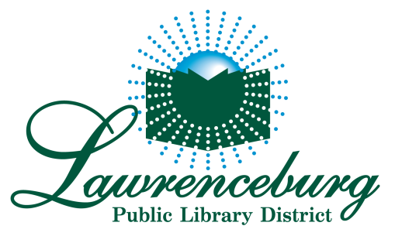

***************************************************************************

I, ________________________________, hereby give permission for my child, _______________________________to use a knife and other kitchen tools under the supervision of the LPLD staff/volunteers during this program. I have read the above on knife safety, and understand both the risks involved and that reasonable care will be taken to ensure my child’s safety. I understand that my child is attending at his/her own risk and if any injury occurs during this event, LPLD staff and volunteers will not be held liable.

Signature of Parent/Guardian: ____________________________

Date: _______________________________